Belgian Meteorite Spectra Calibration
2025-08-06
Samu Syrjänen

Calibration steps:
- Analyze dark images to filter outliers and calculate average dark images
- Subtract dark images from meteorite images
- Match acquisitions that are going to be combined into a reflectance spectra
- Select areas and pixels for the spectra
- Read and filter acquisition setpoints from metadata
- Apply edge correction and derive wavelengths from setpoints
- Read calibration values from calibration standards
- Read meteorite spectra values and derive reflectances
- Smooth the reflectance spectra

1. Analyze dark images to filter outliers and calculate average dark images

We first filter the diagnostic pixels from the sides of the dark images. Although diagnostic pixels covering only a few pixels from each side, it turned out that filtering a couple more pixel rows than necessary provided us with a more uniform statistics. We settled with filtering six pixels from each side of the image.

The entire image is then summarized into a mean and standard deviation. A histogram was used as a help to visualize the image values and spot outliers. To provide more accurate mean and standard deviation estimations, we filtered the outliers by discarding all unique values and values over 12000 from the images.

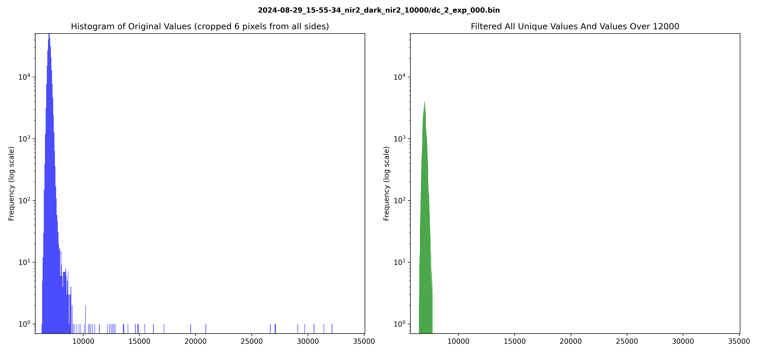

Based on the means and standard deviations, we filtered out the specific dark images that clearly stood out as outliers when comared to other images of the same acquisition. The remaining dark images were then averaged together. As a result we have an average dark image for each channel-exposure pair which can be used to calibrate the images.

2. Subtract dark images from meteorite images

The dark averages are now subtracted from the meteorite images and calibration standards in order to normalize the pixel values. Before the subtraction, six pixels are discarded from each side of the meteorite and calibration standard images, in a similar fashion as in the dark image calibration above.

3. Match acquisitions that are going to be combined into a reflectance spectra

The data is matched based on meteorite name, channel, and exposure. Each spectra is a combination of the vis, nir1, and nir2 channels. In some cases, there are multiple similar acquisitions taken with different exposures. Some of the different exposure acquisitions are more saturated than others, and the best individuals are selected from these candidates. Any overly saturated images are discarded.

Additionally, the corresponding dark averages, calibration standards, and metadata directories are linked to the meteorite images at this point.

4. Select areas and pixels for the spectra

The areas and pixels are selected from distinct meteorite surface locations. The basic idea is to read the values of the image pixels and combine them into a spectra. We gather a spectra for single pixels, 3x3 pixel binnings, and averaged larger areas. To combine a spectra from vis, nir1, and nir2 images, the meteorite shape and surface spots are used to identify identical spots on the meteorite. For the pixel spectras, some navigation lines are used as a help to get more accurate locations from the meteorite surface. An example of an averaged area and pixel locations can be seen in the below images. As a result, each spectra corresponds to a single, semi accurately selected spot on the meteorite surface.

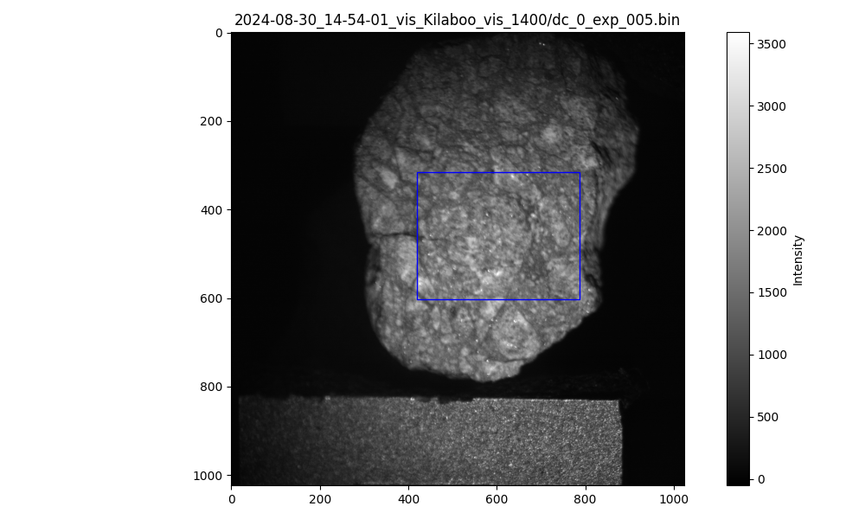
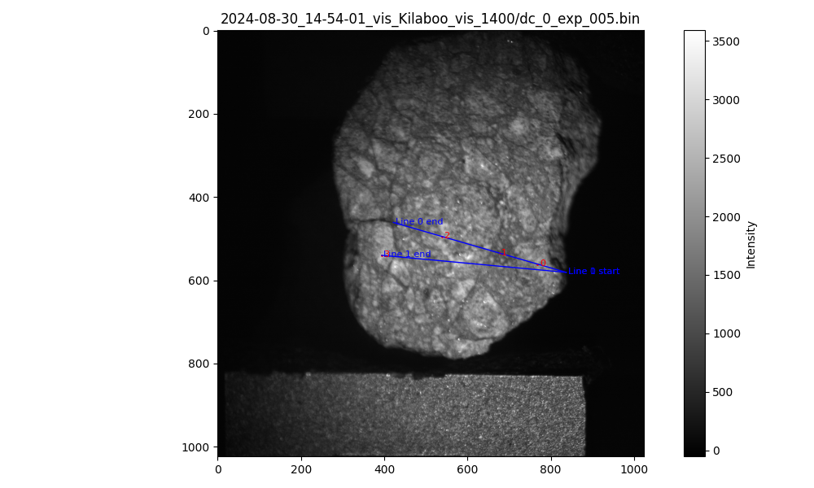

The following list describes the coordinate locations of each single pixel and 3x3 binning spectra.

Allende
0 - CAI
1 - chondrule
2 - dark matrix

ElHammami
0, 2 - dark spots
1, 3 - bright spots

Iran0006
0, 2 - bright spot (0 chondrule?)
1 - dark vein

Kilabo
0, 2 - brighter material
1 - dark shock vein
3 - distinct bright clast

SaU001
0, 1 - dark spots

5. Read and filter acquisition setpoints from metadata

For each acquisition we need to parse the config.json file to determine what setpoints were used in the acquisitions. Each setpoint corresponds to a specific meteorite image. The setpoints and images include some duplicates at the beginning of each acquisition sequence. These duplicates are discarded.

6. Apply edge correction and derive wavelengths from setpoints

A wavelength recalibration is done derive the wavelengths from the setpoints more accurately. An edge calibration image is provided for each setpoint and channel. The edge image average brightnesses are used to calculate the gradient or rate of change across the setpoints. A spline curve is then fit to the gradient in order to accurately interpolate between the setpoints and to find the setpoint value that gives the maximum gradient value. The middle most initial edge setpoint is then subtracted from this new setpoint to derive an edge correction that will be used in setpoint-wavelength transformation equations.

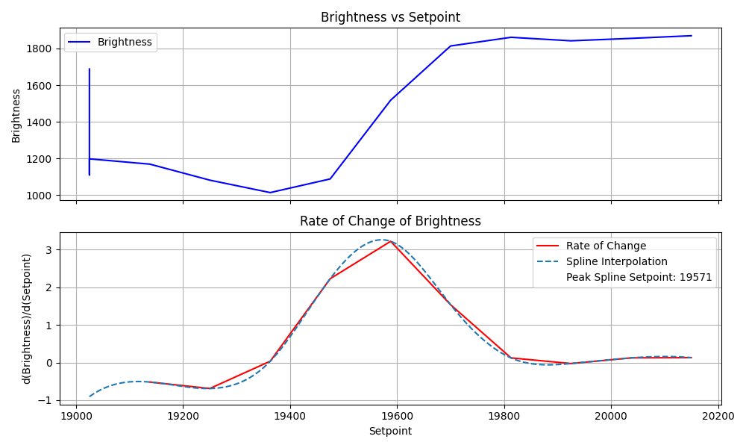
The transformation equations for setpoint-to-wavelength conversions are as follows.

vis, low order:
wl = 0.1256 * (setpoint - edge correction) - 1511.3

vis, high order:
wl = ((setpoint - edge correction) - 12275) / 11.25

nir1, low order:
wl = 0.2696 * (setpoint - edge correction) - 3845.8

nir1, high order:
wl = ((setpoint - edge correction) - 13866) / 7.6772

nir2, low order:
wl = 0.2687 * (setpoint - edge correction) - 3872.6

nir2, high order:
wl = ((setpoint - edge correction) - 14922) / 6.875

The edge peak setpoints are then converted to wavelengths with the new edge correction and compared to the officially documented vis, nir1, and nir2 lower edge wavelengths. The resulting edge peak wavelengths are 649, 851, and 1181, whereas the officially documented vis, nir1, and nir2 lower edge wavelengths are 650, 850, 1200. Since the differences between vis and nir1 results are less than 10 nm, there is no need to apply edge correction when doing setpoint-wavelength conversions. Nir2 has a difference 19 nm so edge correction is needed for nir2. With this information we are now able to derive wavelengths for the meteorite spectra.

7. Read calibration values from calibration standards

The calibration standards are used to derive the reflectance from the image values. The same pixel and area locations are copied from the meteorite images. In cases where those areas are not properly covered by the calibration standard, the calibration coordinates are adjusted slightly. An exampe Kilabo calibration standard is shown below.

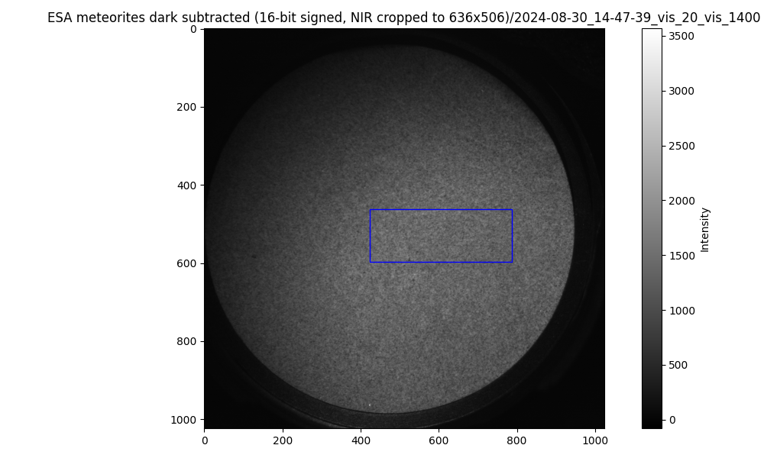
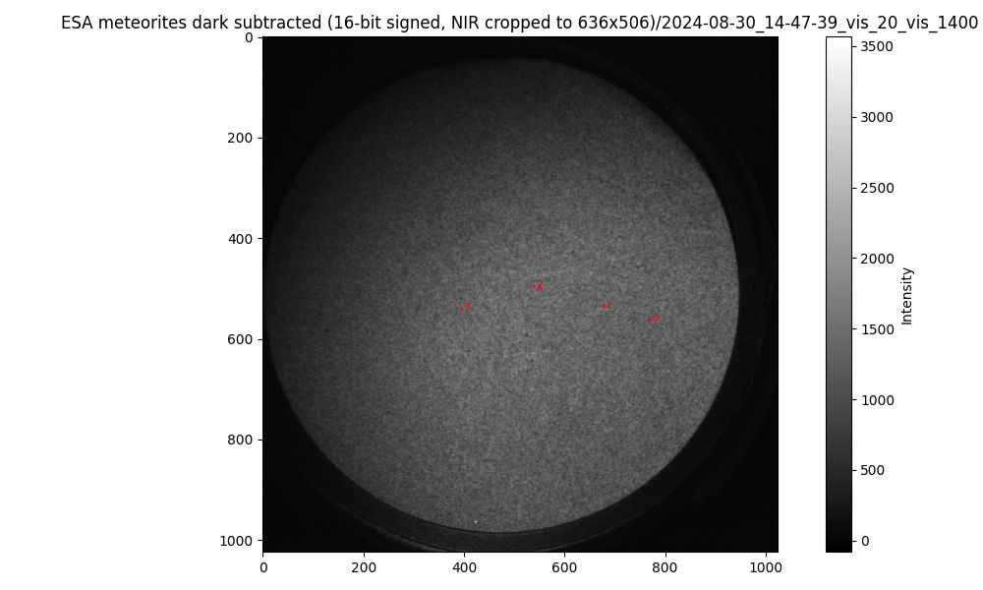

8. Read meteorite spectra values and derive reflectances

Finally, the results of the previous steps are combined to derive the averaged, single pixel, and 3x3 binning reflectance spectra for each selected acquisition set. The reflectances are calculated in the folowing way:
reflectance = image value / calibration standard value * 0.2

Example reflectance of averaged Kilabo:
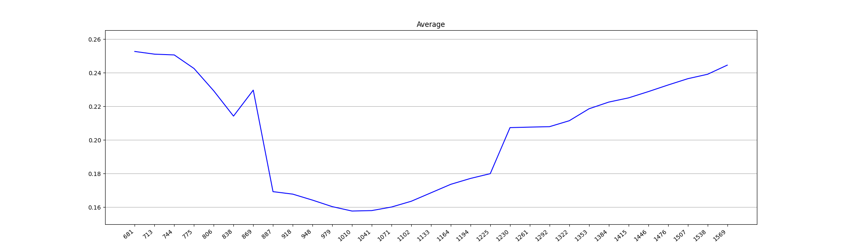

9. Smooth the reflectance spectra

The post calibration adjusts the offsets for channels and deletes outliers in order to increase the quality of the spectra. As an example, we can see from the above image that the nir1 section (the middle) is visibly and consistently at a lower level that vis and nir2. Additionally the last measurement of the vis channel would be considered invalid outlier.

To address these problems, we discard the last vis measurement from all spectra and fit linear regressions to the last and first 3 measurements of nir1 and nir2 respectively. We then select a channel we want to adjust (nir1 or nir2), and calculate an offset for the values so that the two linear regressions cross each other exactly at the boundary of the channels. For the averaged Iran0006 spectra we additionally manually adjust the vis channel. The channels that are adjusted can be seen in the following list for each acquisition set.

Single pixel and 3x3 binning
- SaU001 - No shift
- Kilabo - Shift NIR1
- ElHammami - Shift NIR2
- Iran0006 - Shift NIR2
- Allende - Shift NIR1

Averaged spectra
- Allende - Shift NIR2
- ElHammami - Shift NIR1
- ElHammamiB - Shift NIR2
- Iran0006 - Shift NIR1 and manually adjust VIS
- Kilabo - Shift NIR1

An example smoothed spectra of the averaged Kilabo:
